**UPES**

**PROGRAMMING IN C**

NAME: - SHRESTH BANSAL

SAP ID: -590022218

BATCH: -15

COURSE: -B. TECH CSE

SCHOOL: - SCHOOL OF COMPUTER SCIENCE

SUBMITTED TO: - MS. GAYTRI MAM

EXPERIMENT: 03 OPERATORS

QUESTION 1: WAP a C program to calculate the area and perimeter of a rectangle based on its length and width.

SOL:

#include <stdio.h>

int main() {

float length, width, area, perimeter;

printf("Enter length and width of rectangle: ");

scanf("%f, %f", &length, &width);

area = length * width;

perimeter = 2 * (length + width);

printf("Area: %f\n", area);

printf("Perimeter: %f\n", perimeter);

return 0;

}

OUTPUT

QUESTION 2: WAP a C program to Convert temperature from Celsius to Fahrenheit using the formula: F = (C * 9/5) + 32.

SOL:

#include <stdio.h>

int main() {

float celsius, fahrenheit;

printf("Enter temperature in Celsius: ");

scanf("%f", &celsius);

fahrenheit = (celsius * 9 / 5) + 32;

printf("Temperature in Fahrenheit: %f\n", fahrenheit);

return 0;

}

OUTPUT

QUESTION 3: Obtain the required inputs and compute the areas of the following shapes: (i) Parallelogram (with base and height), (ii) Cuboid (with height, length, width), (iii) Rhombus (with height and side), (iv) Sphere (with radius), (v) Ellipse (with major and minor radius).

SOL:

#include <stdio.h>

int main() {

float base, height, length, width, side, radius, major, minor;

// Parallelogram

printf("Enter base and height of parallelogram: ");

scanf("%f ,%f", &base, &height);

printf("Area of Parallelogram: %f\n", base * height);

// Cuboid Surface Area

printf("Enter length, width, and height of cuboid: ");

scanf("%f ,%f ,%f", &length, &width, &height);

float surfaceAreaCuboid = 2 * (length * width + width * height + height * length);

printf("Surface Area of Cuboid: %f\n", surfaceAreaCuboid);

// Rhombus (Area = base * height)

printf("Enter side and height of rhombus: ");

scanf("%f ,%f", &side, &height);

printf("Area of Rhombus: %f\n", side * height);

// Sphere Surface Area

float PI = 3.14;

printf("Enter radius of sphere: ");

scanf("%f", &radius);

printf("Surface Area of Sphere: %f\n", 4 * PI * radius * radius);

// Ellipse Area

printf("Enter major and minor radius of ellipse: ");

scanf("%f ,%f", &major, &minor);

printf("Area of Ellipse: %f\n", PI * major * minor);

return 0;

}

OUTPUT

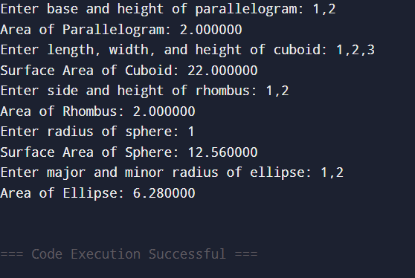

QUESTION 4: Given two numbers. Demonstrate the swapping of the values by using a third variable and without using a third variable.

SOL:

#include <stdio.h>

int main() {

int a, b, temp;

// With third variable

printf("Enter two numbers a,b : ");

scanf("%d ,%d", &a, &b);

temp = a;

a = b;

b = temp;

printf("After Swap : a = %d, b = %d\n", a, b);

// Without third variable

printf("Enter two numbers a,b : ");

scanf("%d ,%d", &a, &b);

a = a - b;

b = a + b;

a = b - a;

printf("After Swap : a = %d, b = %d\n", a, b);

return 0;

}

OUTPUT

QUESTION 5: Convert temperature from Celsius to Fahrenheit and Kelvin.

SOL:

#include <stdio.h>

int main() {

float celsius, fahrenheit, kelvin;

printf("Enter temperature in Celsius: ");

scanf("%f", &celsius);

fahrenheit = (celsius * 9 / 5) + 32;

kelvin = celsius + 273.15;

printf("Fahrenheit: %f\n", fahrenheit);

printf("Kelvin: %f\n", kelvin);

return 0;

}

OUTPUT

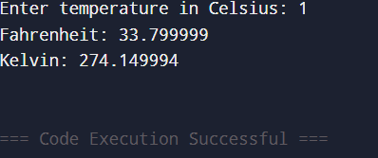

QUESTION 6: Print the given days in years-month-days format. E.g. 396 days = 1 year, 1 month, 1 day.

SOL:

#include <stdio.h>

int main() {

int days, years, months;

printf("Enter number of days: ");

scanf("%d", &days);

years = days / 365;

days = days % 365;

months = days / 30;

days = days % 30;

printf("Years: %d, Months: %d, Days: %d\n", years, months, days);

return 0;

}

OUTPUT

